**Summer Collaborative Appointment NREL-WSU**

***Work Plan for Regionalization and Oilseed***

**Research Question**

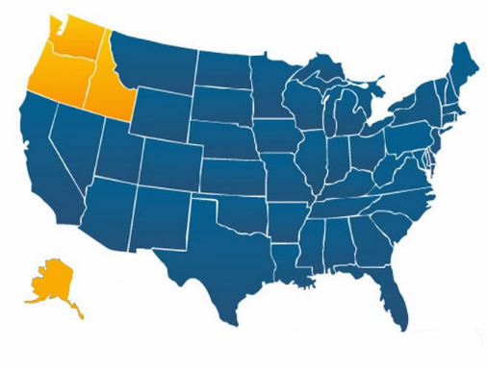

What is the potential AJF production capacity in the PNW (ID, OR, WA)?

**Technologies included**

1. Fischer-Tropsch (FT)
2. Hydroprocessed esters and fatty acids (HEFA)
3. Isobutanol alcohol-to-jet (ATJ)
4. Collocation/Retrofitting of Pulp and Paper facilities (second part)

**Feedstock**

1. HEFA → FOG, Canola and Soy
2. ATJ → Forest residues, Crop residues and herbaceous energy crops
3. FT → Forest residues, woody energy crops, and urban residues
4. Collocation/Retrofitting → Forest residues (second part)

|  |  |  |
| --- | --- | --- |
| **Item** | **Option 1** | **Option 2** |
| Characteristic | Region specific model | BSM (11 Region for the PNW) |
| Regional Array | No | Yes |
| Learning by doing | It is necessary to incorporate an approximation of the learning by doing from other regions in the Nation, which is an approximation from the main model. | Included learning from different technologies and regions in the nation, as the original model |
| Biofuels | Ethanol, Diesel and Jet (maximization for AJF production) | Ethanol, Diesel and Jet (maximization for AJF production) |
| Main data (see 1.) | * State data * Aggregation of information for the new region (ID + OR + WA) in the FS, FM, GP, FL models (see variables below) * Recalculation of tuning variables e.g. K, W | * State data   In the FS, FM, GP, FL models (see variables below)   * Subtraction of CA from original P region, rename P region as PNW, and CA as P→ P=CA and PNW = OR + WA * Subtraction of ID from original M region. * Addition of ID data to PNW * Recalculation of tuning variables e.g. K, W |

**Analysis**

* Due to the main idea is focus on regional analysis the option 1 (Region specific model) is a better approximation

**If**

1. All the feedstock and logistic data come from a state basis
2. It is possible to incorporate exogenously the learning by doing from the nation
3. **Main data change per Model**
4. *Grower Payment (GP)*
   1. Cash Rent by Region Annual Payment
   2. harvest frac annual
   3. Inital Annual YPA nominal units
   4. INITIAL Crop PCPA
   5. INITIAL Hay PCPA
   6. Initial Hay YPA
   7. INITIAL HC PCPA by yr
   8. Initial HC YPA by yr
   9. Initial Res Nutrient replace CPT
   10. INITIAL WC PCPA by yr
   11. Val Sec Crop as Frac
   12. BAY WC YPA
5. *Feedstock Supply (FS)*
   1. INITIAL CRP land by region
   2. initial Hay Land by region
   3. initial land distns by crop by region
   4. INITIAL pasture land by region
   5. Initial Pasture PCT in Pasture
   6. K
   7. urban residue prod
   8. Cell Transition Time
   9. W PCEC
   10. W hay
6. *Feedstock Market (FM*)
   1. Initial Crop regional prices
   2. initial regional distn fs export
   3. regional distn of cellulose capacity
7. *Feedstock Logistics (FL)*
   1. Advanced Ag Res HCCPA
   2. Advanced HC HCCPA
   3. Advanced WC HCCPA
   4. C to EtOH Adv Q H
   5. C to EtOH Conv Q H
   6. C to RR Adv Q H
   7. C to RR Conv Q H
   8. Conventional Ag Res HCCPA
   9. Conventional HC HCCPA
   10. Conventional WC HCCPA
8. **Inclusion of oilseed production**

|  |  |
| --- | --- |
| Canola as feedstock | * Inclusion of canola as feedstock   + Include logic that change wheat into canola (see 2.1.)   + Include canola into the crop array (see 2.2) |
| Pretreatment | * Inclusion of canola crushers (mills) as pretreatment   + Canola preprocessing cost in FL module (does not include NPV and attractiveness of the facility) |
| Imports | * International (Canada) and inter-regions (Montana) imports of canola oil   + Use similar logic than the imports module of EtOH comparing Canola oil price at conversion gate vs (Canola oil price at region port + transportation) |

* 1. **Option A**
     1. Initializations
        + Split the Initial land distns by crop by region into the crop land that can be transform into cellulosic energy crops and oilseed crops or include canola into the [annual crop] array



* + 1. Include a logic that transform cropland to oilseed crops following the logic from crop land to Cellulosic Energy Crops



* + 1. Continue to incorporate parts of the BSM logic to include Oilseeds as energy crops
  1. **Option B**

1. Include canola into the [Annual Crop] Array
   1. For OHC
      1. Include Canola into the Cost Demand and Constraints on Utilization Sector and feedstock logic
   2. Crop switch open for the region of interest (PNW)
   3. Recalculate K, dealloc rate Annual
   4. Modification of the initial land dist by crop by region
   5. Inclusion in Main data for Canola
   6. Calculate graphical functions